Module 5 单元侧试题
I. 单项选择(15分)
1._____ great efforts we failed to carry our plans through.
A. In spite B. Because of C. But for D. In spite of
2. ______the beginning of the year they were like strangers. But now they are good friends.
A. On B. At C. With D. By
3. -When will you go abroad? Next week? -__________.
A. That depends B. That depends on C. That will depend D. That will depend on
4. Dark glasses are sometimes worn to ______ the eyes from strong sunlight.
A. prevent B. care C. defend D. protect
5. The father as well as the mother and their children _______ to make up a trip to Beijing.
A. wish B. wishes C. are wishing D. have wished
6. Our English teacher loves us very much and he ________.
A. thinks well of B. is thought well C. is well thought of D. is well thinking
7.-Shall we go out for a walk or stay at home? -Which ______ do yourself?
A. would you rather B. would you like C. had you better D. do you feel like
8. Some countries may be _______but can never be ________.
A. defeating; conquering B. conquering; defeating C. defeated; conquered D. conquered ; defeated
9. Last year the well-known actress did all ____ help the poor children in that mountain village.
A. she could do B. she could to C. what she could to D. that she could
10. Jim is not ________ as his sister.
A. good as a student B. as good a student C. as a good student D. an as good student
11. Nowhere in the world ______ a man who loves you so much.
A. you may find B. may you find C. you can find D. can you find
12. --- Do you like the music? -----Yes, it _____ beautiful.
A. is sounding B. sounded C. sounds D. is sounded
13. If we work with a strong will, we can overcome the difficulty, _____ great it is.
A. whichever B. how C. whatever D. however
14. ----I don’t think Tom has ever been to Iceland. ----_________.
A. Nor Mary does B. Mary doesn’t either C. Mary hasn’t too D. Nor has Mary
15. I’m sorry to say that I can’t imagine such a gentleman ____ be so rude to a lady.
A. might B. should C. would D. could
II. 完形填空（共20题；每小题1.5分，满分30分）
Tom picked up a piece of string(绳子) on his way to the market. He was 16 to roll it up when he noticed Malandain was 17 him. As he had quarreled with Malandain, he felt a bit of 18 at being seen thus by his 19 . So he hurriedly 20 the string, 21 to look for something else and then walked to the market.
He soon lost himself in the marketing 22 . When noon came, he joined the 23 at Jourdain’s. While he was drinking, he first heard the public crier announce the 24 of a wallet and then 25 name called by the crier, who told him to 26 at the mayor’s office.
It was there that he 27 that he was said to have 28 the wallet by Malandain. In 29 he insisted on his innocence(无辜) 30 by showing the 31 and then asked for face to face with Malandain. It was not until he was 32 that the mayor let him leave.
Tom continued to defend, but the more he defended, the less he was believed, 33 the wallet was found. He grew 34 and soon took to his bed.
Several months later he died in anger, still insisting on his innocence, 35 ,“A little piece of string—a little piece of string—see, here it is.”
16. A. about B. able C. sure D. certain
17. A. seeing B. looking C. noticing D. watching
18. A. shyness B. regret C. shock D. shame
19. A. enemy B. friend C. visitor D. villager
20. A. threw B. hid C. rolled D. led
21. A. tried B. pretended C. got D. decided
22. A. crowd B. thought C. work D. imagination
23. A. meal B. buying C. returning D. game
24. A. loss B. finding C. price D. robbery
25. A. his own B. his enemy’s C. the mayor’s D. someone’s
26. A. sit B. appear C. come D. wait
27. A. told B. knew C. learned D. promised
28. A. thrown away B. given up C. taken back D. picked up
29. A. silence B. danger C. anger D. time
30. A. first B. second C. then D. finally
31. A. wallet B. string C. heart D. money
32. A. sentenced B. beaten C. questioned D. searched
33. A. just before B. as soon as C. only when D. even after
34. A. thinner B. angrier C. happier D. surer
35. A. believing B. thinking C. repeating D. presenting
III. 阅读理解（共20小题；每小题2分，满分40分）
A
It was an early September day, cool and bright and just right for running, and I was in the first few miles of a 10-mile race over a course (路线) with a few high hills. Still, I felt energetic; despite the hills it was going to be a fine run.
Just ahead of me was Peggy Mimno, a teacher from Mount Kiseo, New York. She too was running easily, moving along at my speed. The pace (步速) felt comfortable, so I decided to stay where I was; why pay attention to pace when she was setting such a nice one? I’d overtake (追上) her later on when she tired.
So I ran behind her. The course headed north for miles, wandered west for a hilly mile, then turned south again along a winding road. The race was getting harder. We had four miles left and already it was beginning to be real work.
Peggy overtook a young runner. She seemed to known him, for they exchanged a few cheerful words as she passed him. Their exchange worried me. You don’t chat during a race unless you feeling good, and Peggy plainly was.
Still, I was close enough to overtake her if she tired, so I didn’t give up hope completely. We were getting nearer to a long, punishing hill now and it would be the test. We were a mile from the finish line, so whatever happened on the hill would almost determine who crossed it first.
As I moved up the hill, my attention wandered for a few minutes. When I looked up, Peggy was moving away-first five yards, then ten, then more. Finally it was clear that there was no help of catching her. She beat me soundly.
There is an important lesson in that race. Women are thought to be weaker, slower and not nearly as skilled in sport. Yet as Peggy Mimno so clearly showed, the similarities between men and women runners are more important than differences. I have run with a number of women, and I can say it is often hard work..
36. What did the writer think of the race in the beginning?
A. It would be hard work. B. It would be an easy race.
C. It would be a test of his strength. D. It would be a good learning experience.
37. What worried the writer when Peggy greeted the young runner?
A. Peggy overtook the young runner. B. Peggy was running energetically.
C. Peggy was laughing as the writer. D. Peggy paid no attention to the writer.
38. By saying “a long, punishing hill” (paragraph5), the writer implies that ______.
A. Peggy would fail to reach the hilltop B. men are more skilled at climbing hills
C. overtaking Peggy would be easy D. climbing the hill would be a demanding task
39. What lesson dose the writer learn from the race:
A. Women are as good as men in sport. B. Women are better at climbing hills.
C. He should have more training in a cross-country race.
D. He should set a quicker pace at the beginning of a race.
B
About ten years ago, a young and very successful businessman named Josh was traveling down a Chicago neighborhood street. He was going a bit too fast in his shiny, black, 12 cylinder Jaguar XKE, which was only two months old.
He was watching for kids rushing out from between parked cars and slowed down when he thought he saw something. As his car passed, no child came out, but a brick sailed out and-WHUMP!-it hit the Jag’s shiny black side door! SCREECH... !!!! Immediately Josh stopped the car, jumped out, seized the kid and pushed him up against a parked car. He shouted at the kid, “What was that all about and who are you? Just what the heck are you doing?!” Building up a head of steam, he went on.“That’s my new Jag, that brick you threw is gonna cost you a lot of money. Why did you throw it?”
“Please, mister, please... I’m sorry! I didn’t know what else to do!” begged the youngster. “I threw the brick because no one else would stop!” tears were streaming down the boy’s face as he pointed around the parked car. “It’s my brother, mister,” he said. “He rolled of the curb （路沿）and fell out of his wheelchair and I can’t lift him up.” Sobbing, the boy asked the businessman, “Would you please help me get him back into his wheelchair?” he’s hurt and he’s too heavy for me.”
Moved beyond words, the young businessman tried hard to swallow the rapidly swelling lump in his throat. Straining, he lifted the young man back into the wheelchair and took out his handkerchief and wiped the scrapers and cuts, checking to see that everything was going to be OK. He then watched the younger brother push him down the sidewalk toward their home.
It was a long walk back to the black, shining, 12 cylinder Jaguar XKE — a long and slow walk. Josh never did fix the side door of his Jaguar. He kept the dent （凹痕）to remind him not to go through life so fast that someone has to throw a brick at him to get his attention. Feel for the bricks of life coming at you.
40．The boy threw a brick at the businessman’s car because ________.
A. the businessman drove at a high speed B. he envied the brand-new car very much
C. he wanted to ask for some money D. he wanted to get help from the driver
41．Which of the following is the right order of the story?
a．The younger brother threw a brick at Josh’s car. b．The elder brother fell out of his wheelchair.
c．The younger brother begged Josh for help. d．Josh lifted the elder brother back into his wheelchair.
e．Josh shouted at the younger brother.
A. b, a, e, c, d B. a, c, d, b, e C. b, a, c, e, d D. a, c, b, e, d
42．What can we learn from the passage?
A. Josh would accept the money from the kids. B. The two kids were Josh’s neighbors.
C. Josh was a kind-hearted man. D. Josh’s new car broke down easily.
43．According to the passage, the last sentence means ________.
A. trying to get ready for the trouble in your future life
B. driving fast in a neighborhood street is dangerous
C. trying to be more understanding seeing others in trouble
D. protecting oneself from being hurt
C
Experts have put forward detailed plans to a tunnel (隧道) to join Taiwan with the Chinese mainland.
The shortest proposed route would be 126 kilometers-more than twice the length of the English Channel Tunnel. And the longest proposed route would be 207 kilometers.
A recent conference in Xiamen, Fujian Province brought together more than 70 experts. The event was co-sponsored (共同发展) by universities from Taiwan and the Chinese mainland.
Fujian is the province where both proposed routes would begin.
There is no direct passenger access (通道) between the mainland and Taiwan by air or sea at the moment.
Experts say that it is better to start research sooner rather than later, although there is a lack of government funding. There are no technical problems to build a Taiwan tunnel. But it will require an improved political relationship across the Straits.
A professor of Tsinghua university said, "A special feature of huge projects is that the period of preparation is longer than the period of construction."
For example, he said, the English Channel Tunnel took 14 years of planning and had been discussed for two centuries. And preparations for the huge Three Gorges dam on the Yangtze River began in the 1950s.
The Xiamen conference focused (集中) on the longest southern route., which would use the Taiwan-controlled islands of Jinmen and Penghu as stepping stones.
The first stage of the new project could be a bridge to cross the five kilometers between Xiamen and Jinmen. This would mean that travelling from Xiamen to Jinmen by car would only take five minutes.
The longest tunnel now being planned anywhere in the world is the 54-kilometer Land tunnel to link Lyon in France with Turin in Italy. The tunnel will not be completed until 2015-2020.
44. Which is the longest tunnel in the world at present?
A. The English Channel Tunnel. B. The tunnel between Lyon and Turin.
C. The Taiwan Straits tunnel. D. The passage doesn't mention it.
45. The example of English Channel Tunnel shows _______.
A. it's not easy to complete a huge project
B. there are many problems to be solved before doing something
C. discussions among countries usually take a lot of time
D. the preparation takes longer time than the construction
46. Which of the following is NOT true?
A. Universities both at home and abroad have sponsored (赞助) the plan.
B. If the project is completed, the world's longest tunnel will appear.
C. You can't reach Taiwan from the mainland directly at present.
D. The starting point of the proposed tunnel is in Fujian.
47. What is the possible difficulty in carrying out the plan?
A. The lack of money for the project from the government.
B. Improving the relationship between Taiwan and the mainland.
C. The detailed plans for the tunnel.
D. The technical problems with the tunnel.
D
Help Wanted | Help Wanted | Help Wanted | Help Wanted
PAINTER Must have at least 3 years painting experience. Commercial and new construction work. $10/hr. Immediate opening. Call 4359201 with work history.  ~~~~~~~~~~~~~~~~  SECRETARY Part time position available in friendly, busy office. Good typing and general office skills. Some weekends required. High pay. Various duties. Apply(申请) at East Side Management, 500 Park Drive, DeWitt, NY. 13214. | VETERINARIAN ASSISTANT(兽医助理)Person needed for busy animal hospital. Some nights and weekends. Apply in person to JohnsonMarks Animal Hospital, 404 Snow Road, Syracuse, NY. 13224. After 4 p.m.only please.  ~~~~~~~~~~~~~~~~  NURSES’ ASSISTANTS  Full time and parttime positions available for modern nursing home. High pay. Call Mrs. Downes, R.N. at  5347618. | COOK NEEDED  Immediately. Busy downtown restaurant. Must be good and dependable. Experience preferred. Weekends required. Call 3249817.  ~~~~~~~~~~~~~~~~~  SALESPERSON  Experienced. Must have some knowledge of men’s clothing industry. Available to work evenings and some Saturdays. Send resume(个人简历) to: Martin’s Apparel, 237 Rockledge St.,  Syracuse, NY. 13224. | TEACHER Small private school needs English and maths teachers. Must have BS degree and at least 4 years teaching experience. Send resume to: Wales Charter School 19 South 8th St. NY. 13214.  ~~~~~~~~~~~~~~~~  HOTEL needs parttime FRONT DESK CLERK No experience necessary. Excellent people and phone skills a must. Some computer  skills helpful.$ 13/hr.  Call: Mr. Jones 3572897.
48. If you are interested in working in a hotel, call.
A. 4359201 B. 5347618 C. 3249817 D. 3572897
49. If you want to get a job as a maths teacher, send your resume to .
A. 237 Rockledge St., Syracuse, NY. 13224 B. 404 Snow Road, Syracuse, NY. 13224
C. 500 Park Drive, DeWitt, NY. 13214 D. 19 South 8th St. NY. 13214
50. If you dislike working on Sundays, being a should be your best choice.
A. cook B. secretary C. salesperson D. veterinarian assistant
51. If you want to get a job at , you must have office skills.
A. Martin’s Apparel B. East Side Management
C. Wales Charter School D. JohnsonMarks Animal Hospital

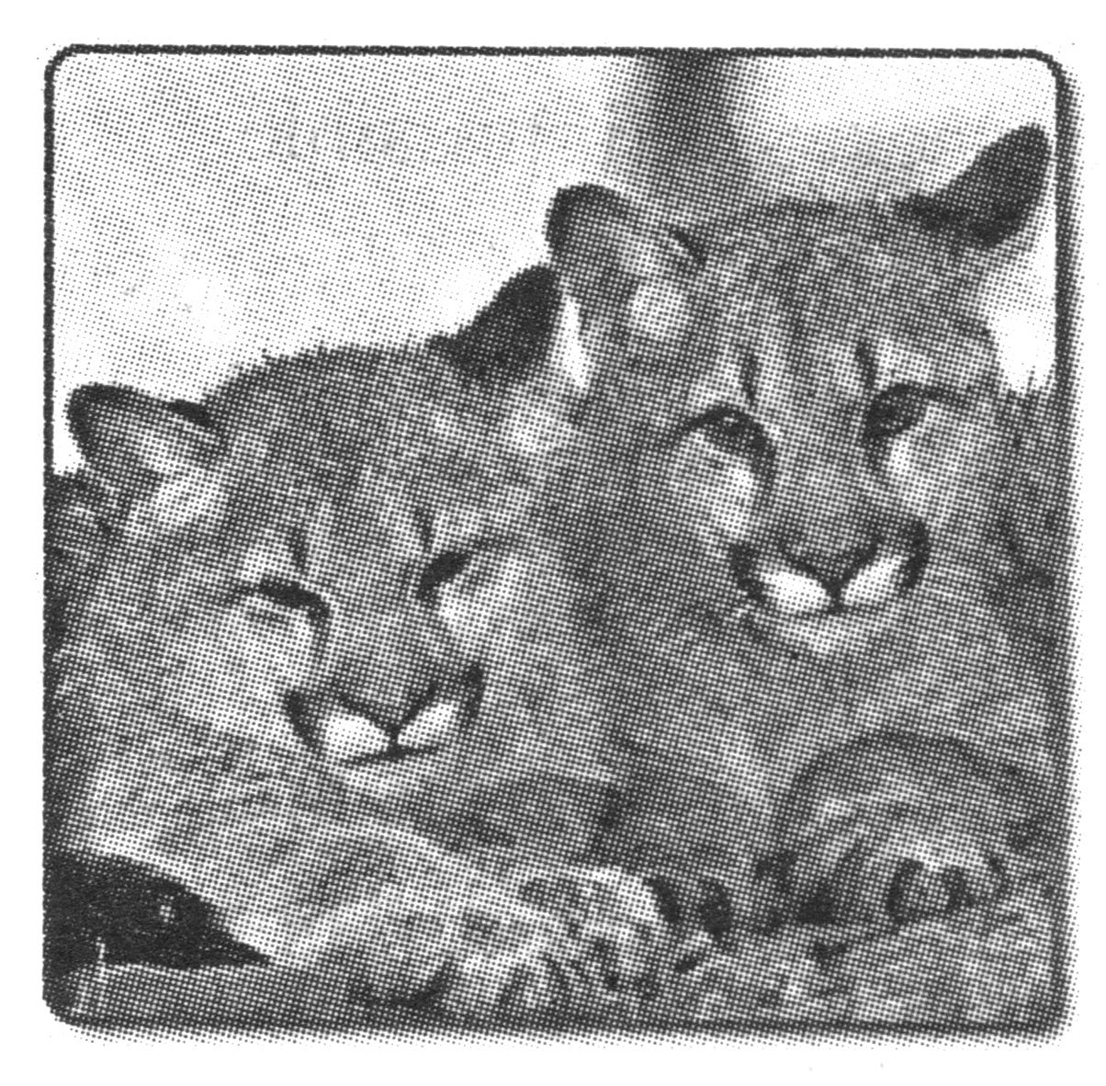
E
Mountain lions live in mountainous areas of the western United States. Lately, however, people have reported seeing them in quiet neighborhoods all across the country! Usually considered shy and seldom seen, these lions are becoming more noticeable. In addition, the lions appear to be moving east. They were even reported in the suburbs (郊区) of Boston, Philadelphia, and Chicago.
It seems certain that these “kings of the mountains” are moving. Why? Scientists are not sure. Some think that as the mountain lion population increases in the west, younger wild cats are leaving the area. These cats are searching for new homes and new places for food.
“The young males are looking for new homes,” says Lynn Sadler, who is the director of the Mountain Lion Foundation in Sacramento, Calif. “People tend to create too many barriers (障碍), such as buildings, fences, roads, and noise. As the mountain lions seek new places and food and water sources (水源) , these barriers get in their way.”
The sightings have made people increasingly watchful. Sometimes the “mountain lions” that people report seeing turn out to be large dogs or even house cats. But at least a few of the meetings have been real. The building of new roads, the growing of suburbs and the growing popularity of outdoor activities are all increasing the chances that people in various parts of the country may meet up with a mountain lion.
Because many people are concerned about the reappearance of the American lion, an expert outlined some ways they can avoid attracting the wild cats: Never leave pets or pet food outside; properly care for farm animals; and plan public land use to enable the lions to move safely from one place to another.
“To be fair,” says the expert, “mountain lions are trying to regain their homes. They were here first. Now we need to find ways we can live together.”
52. Mountain lions are moving probably because .
A. the suburbs of big cities are peaceful and quiet
B. more roads are being built into the mountains
C. the number of the lions increases in the west
D. young lions are seeking new partners
53. According to the passage, it is clear that .
A. the reported sightings of mountain lions have not been proved
B. people walking in the country may come across a lion
C. fences have been built to protect the lions
D. mountain lions prefer populated areas
54. To avoid attracting mountain lions, people are advised .
A. to build more roads for the lions to move safely
B. to keep a close watch on their farm animals
C. not to stay outdoors
D. not to raise pets
55. Which is the best title for the passage?
A. Mountain Lions in Unlikely Places B. Measures Taken to Avoid Lions
C. Number of Sightings Going Up D. Mountain Lions Moving West
IV. 写作（共三节）
第一节：汉译英（共5小题；每小题3分，满分15分）
56．良好的开端是成功的一伴。

57．乔被公认为是今年最佳篮球选手。（acknowledge）

58．警方控告他犯有盗窃罪。

59．人们过去常根据收音机对表。

60．他虽然是个孩子，但已经熟知英语。

第二节 书面表达（满分20）
假设你是李华，在一所中学读书。最近收到美国朋友Smith先生的来信，他希望了解有关中国教育方面发生的巨大变化。请参照下面表格所提供的内容，给他写一封回信，介绍这方面的情况。
注意：1．回信必须包括表格中的所有内容，可以适当增减细节，使内容连贯。
2．词数100左右。
3．开头和结尾已为你写好（不记入总词数）
成人adult；改革开放政策reform and opening-up policy
时间 | 情 况
1949 | 20%的儿童入学，80%的成人不会读写
改革开放后 | 教育迅速发展  在过去的20年中，50万学生被派往100多个国家，迎接了从164个国家返回的14万留学生（returned student），他们在国效力。
现在 | 所有公民享有平等受教育的权利，98%以上的儿童入学。
Jan. 27
Dear Mr Smith,
I was so pleased to hear from you and I am writing to tell you something about education in China.

I hope you can come and see for yourself some day.
Best wishes
Yours
Li Hua
参考答案
I.单项选择题1-15 DBADB CACBB DCDDB
II.完形填空16-35 ADDAB BAAAA BCDCA BDDAC
III.阅读理解36-55. BBDA DACC DDAB DDCB CBBA
IV. 汉译英
56．A good beginning is half the battle.
57．Joe is acknowledged as the best basketball player of the year.
58．The police accused him of stealing.
59．People used to set their watches by the radio.
60．Child as / though he was, he had a good command of English.
书面表达
Dear Mr Smith,
I was so pleased to hear from you and I am writing to tell you something about education in China.
Great changes have taken place in education. When the People’s Republic of China was founded in 1949, only 20% of the children had the chance to go to school. And about 80% of the adults could neither read nor write. To our joy, since our country carried out reform and opening-up policy, education has developed rapidly. In the past twenty years, China has sent as many as 500,000 students to more than 100 countries and has received about 140,000 returned students from 164 countries. They are all working hard. Now all citizens enjoy equal education rights. All over the country, more than 98% of the children are attending school.
I hope you can come and see for yourself some day.
Best wishes
Yours
Li Hua

